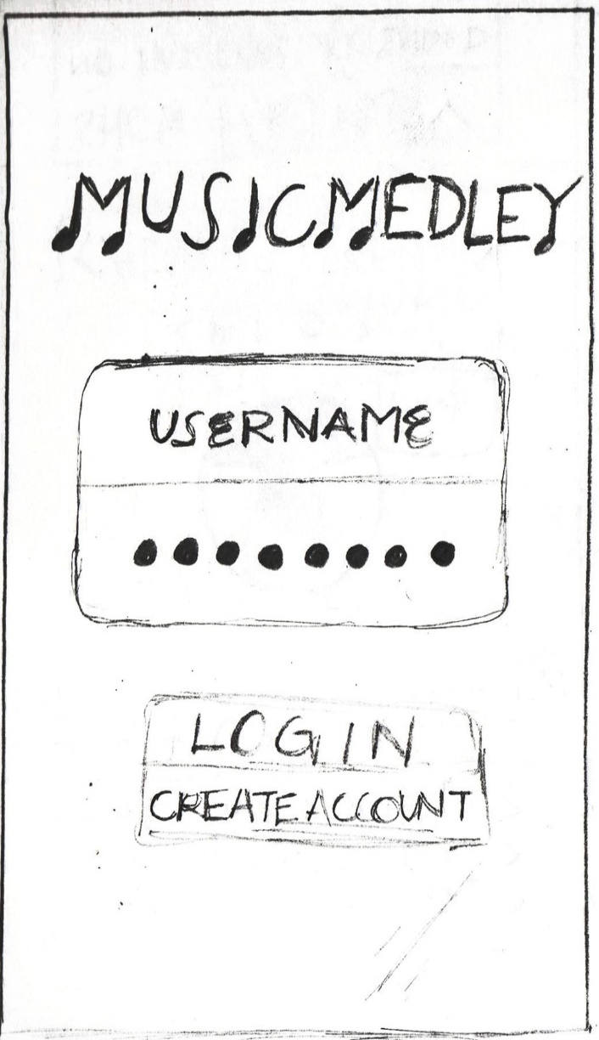**Login Activity**

OPTIONS:  
A. Enter correct login credentials, tap “login” (Go Page 5)  
B. Enter invalid or blank login credentials, tap “login” (Go Page 4)  
C. Enter non-existing username, tap “login” (Go Page 4)  
D. Tap “Create Account” (Go Page 2)

**Create Account Activity**

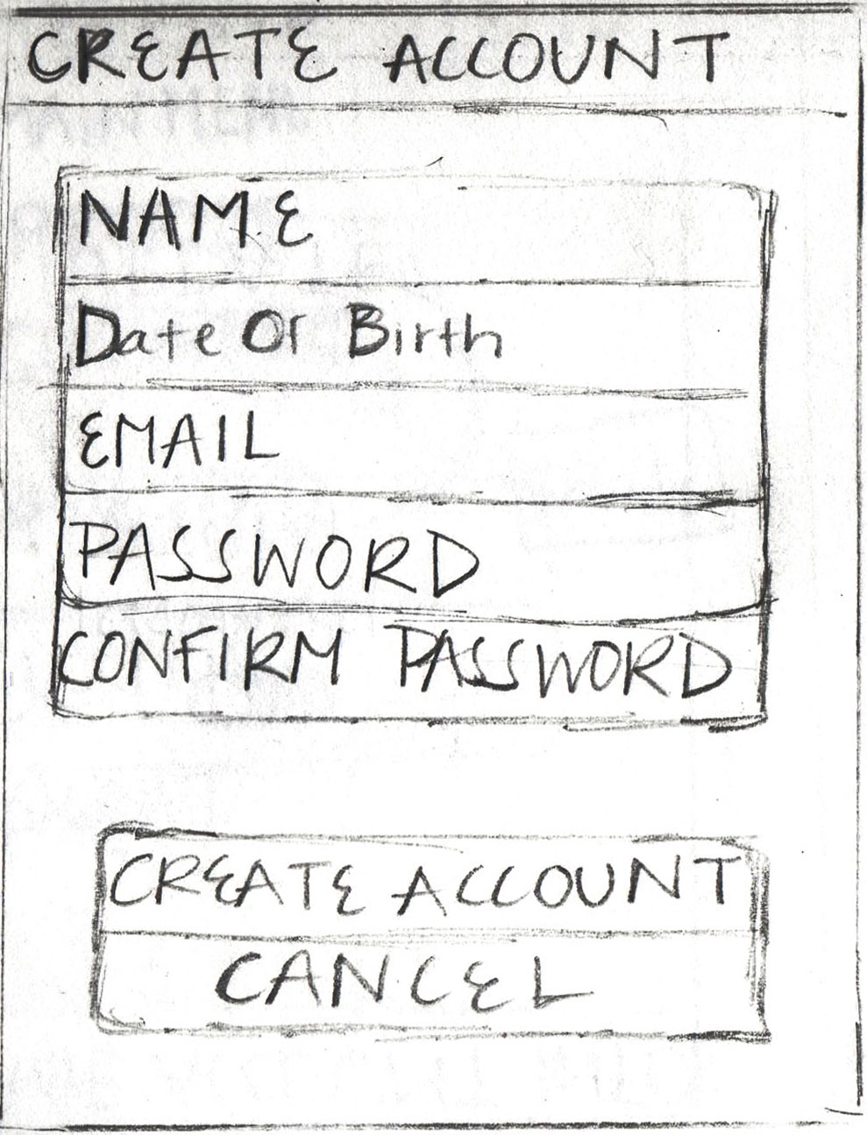

OPTIONS:  
A. Leave any field blank, tap “Create Account” (Go Page 3)  
B. Enter non-matching password fields, tap “Create Account” (Go Page 3)  
C. Enter already existing username, tap “Create Account” (Go Page 3)  
D. Enter already existing email, tap “Create Account” (Go Page 3)  
F. Enter new and valid credentials, tap “Create Account” (Go Page 1)  
 ** Toast MSG: “Account Creation Successful” **  
G. Tap “Cancel” button to cancel New Account (Go Page 1)

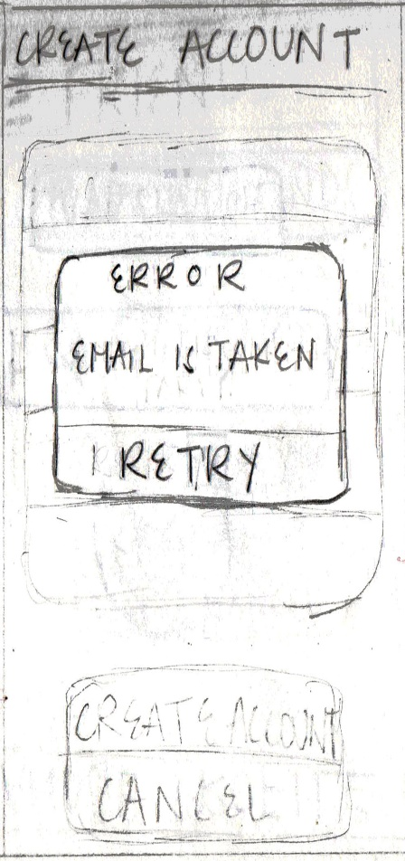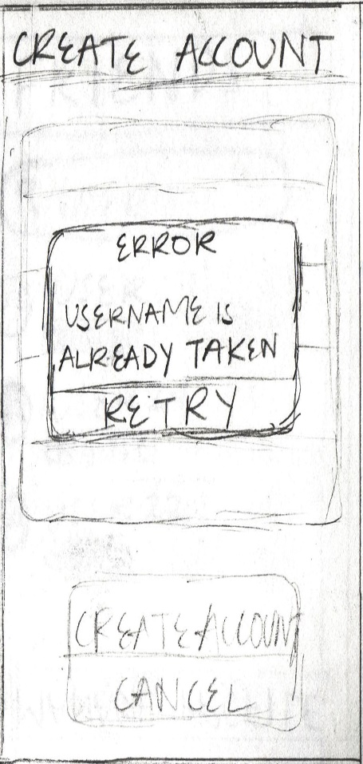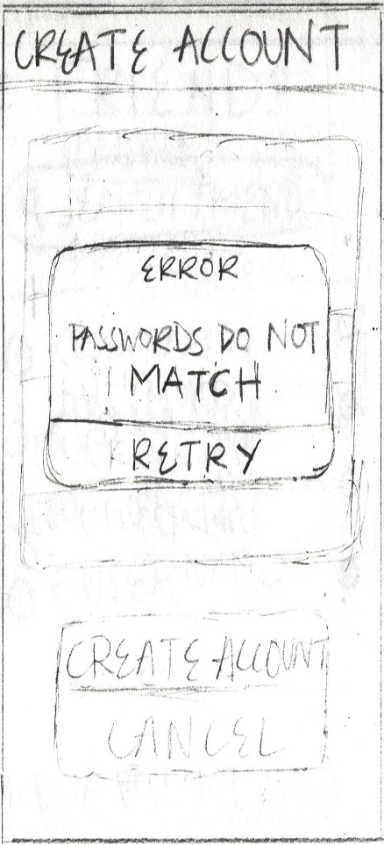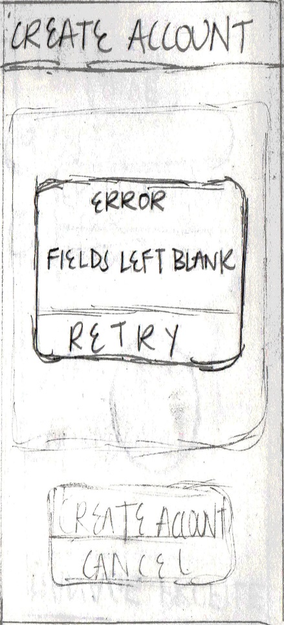**Create Account Activity (“Create Account” Error 1, 2, 3, & 4)**

All Errors: Tap “Retry” button, (Return Page 2)

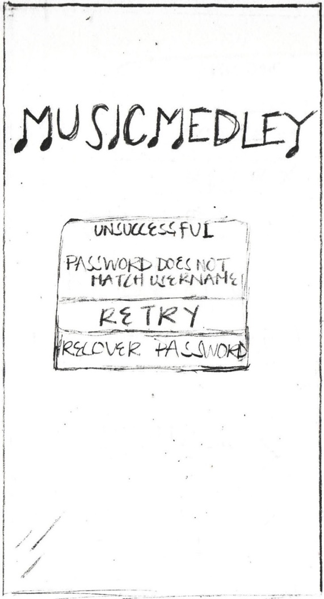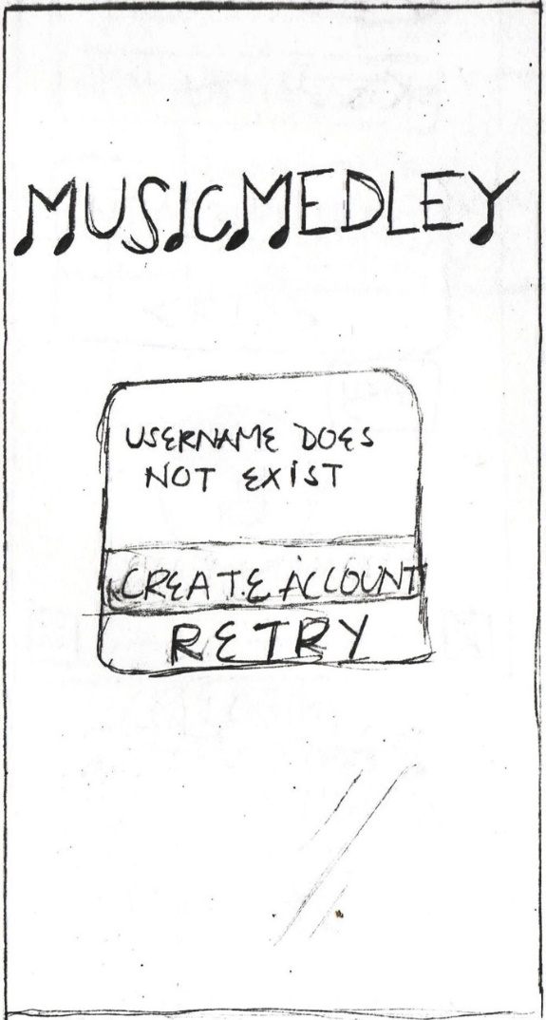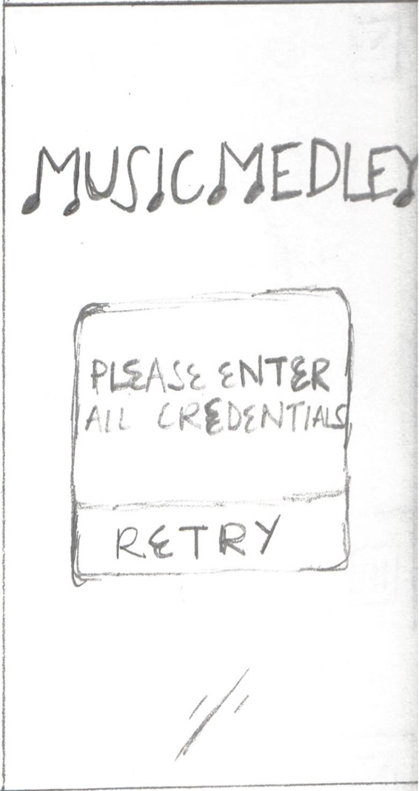**Login Activity (“Login” Error 1, 2, & 3)**

Error 1 (Left): Tap “Retry” Button, (Return Page 1)

OPTIONS Error 2 (Middle):  
A. Tap “Retry” Button, (Return Page 1)  
B. Tap “Create Account” Button, (Go Page 2)

OPTIONS Error 3 (Right):  
A. Tap “Retry” Button, (Return Page 1)  
B. Tap “Recover Password”, (Go Page 1)   
 ** Toast MSG: “Recovery Email Sent to <account email>” **

**Profile Activity \***

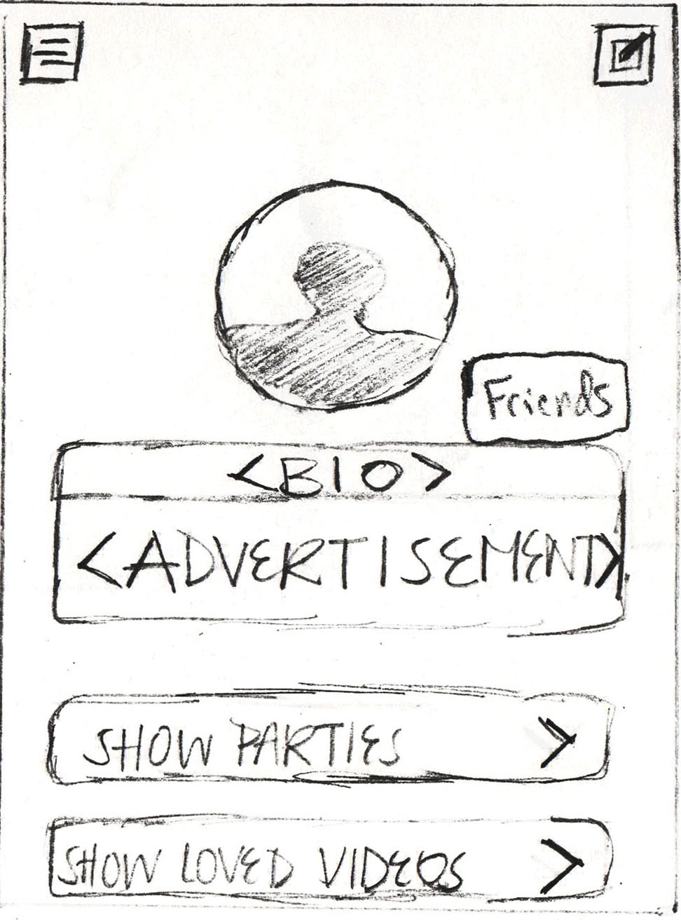

OPTIONS:  
A. Select “Show Parties” Dropdown, (Go Page 6)  
B. Select “Show Loved Videos” Dropdown, (Go Page 7)  
C. Select “Edit” Icon, (Go Page 8)  
D. Select “Friends Button”, (Go Page 11)  
E. Select “Hamburger Menu” Icon, (Go Page 13)

**Profile Activity (“Show Parties” dropdown selected)**

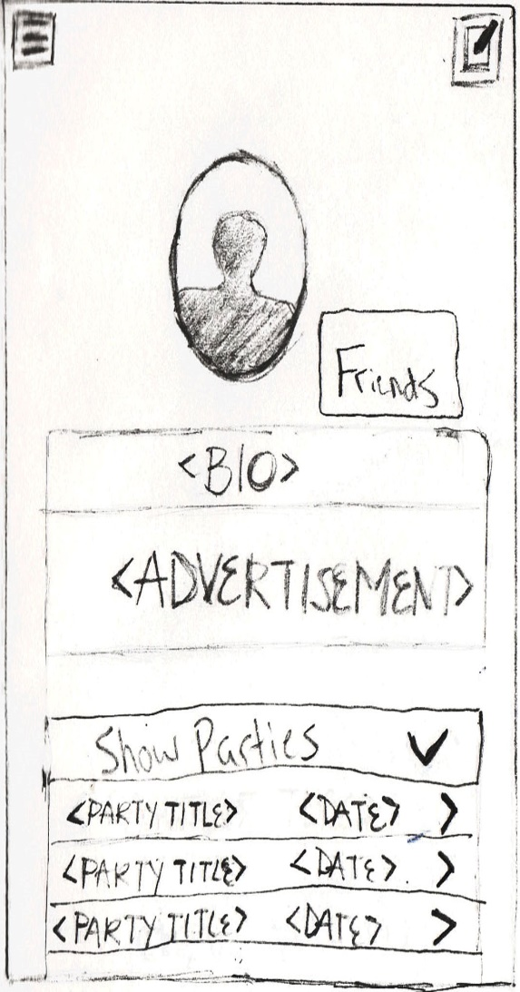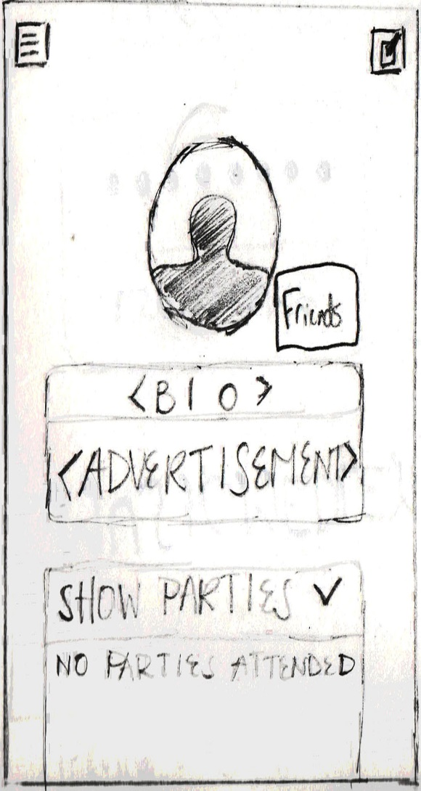

OPTIONS: Collapse Drop down, (Return Page 5)

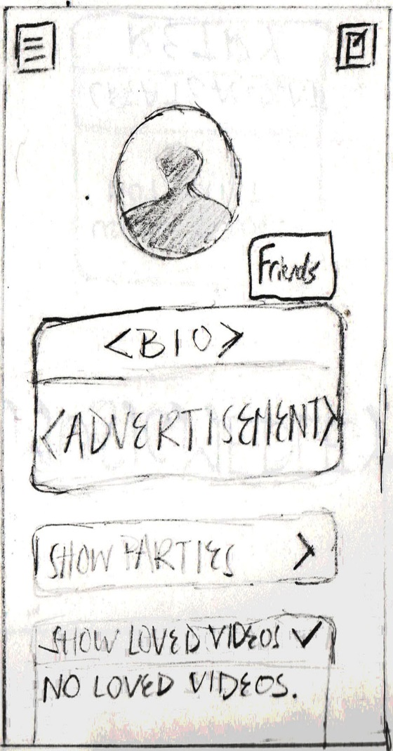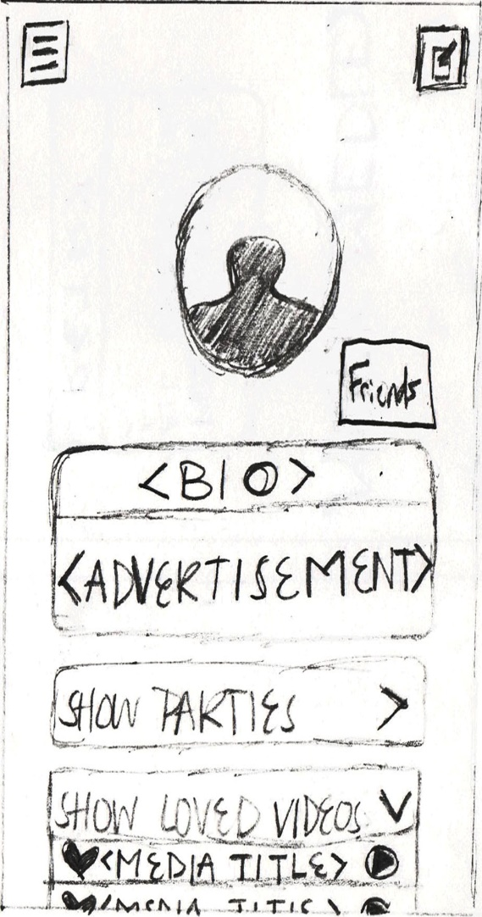**Profile Activity (“Show Loved Videos” dropdown selected)**

OPTIONS: Collapse Drop down, (Return Page 5)

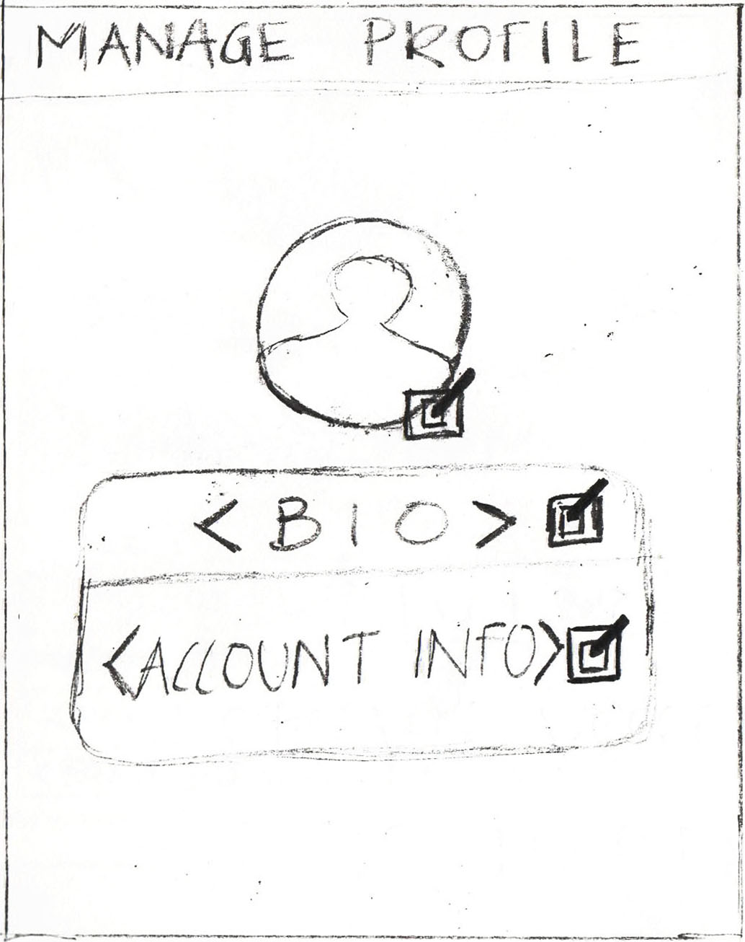**Manage Profile Activity**

OPTIONS:  
A. Select Profile Picture’s “Edit” Icon, (Go Page 9 (Left))  
B. Select Bio’s “Edit” Icon, (Go Page 9 (Right))  
C. Select Account Info “Edit” Icon, (Go Page 10 (Left))

NOTES:  
*Needs Cancel button*  
D. Tap “Cancel” Button to cancel, (Return Page 5)

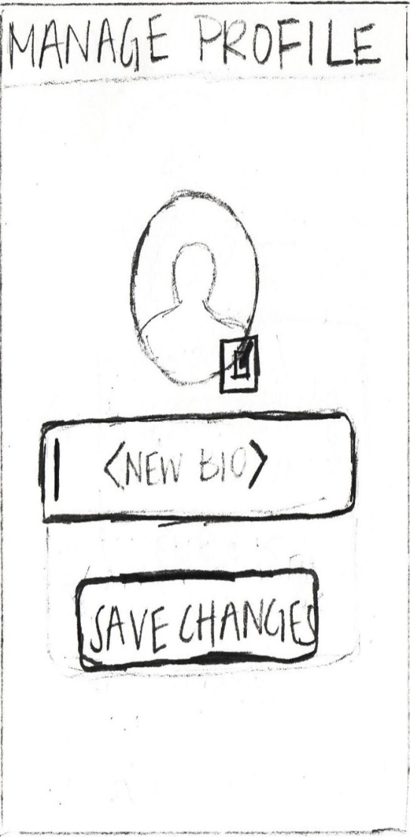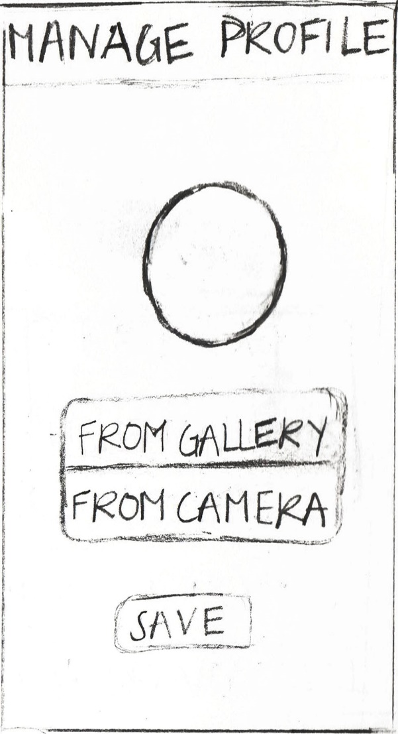**Manage Profile Picture & Bio Activities**

OPTIONS Manage Profile Picture (Left):   
A. Select “From Gallery”, select photo, tap “Save” Button, (Return Page 8)  
B. Select “From Camera”, take Photo, tap “Save” Button, (Return Page 8)

OPTIONS Manage Bio (Right):  
A. Enter New Bio, select “Save Changes” button (Return Page 8)

NOTES:  
*Needs Cancel button*  
C. Tap “Cancel” Button to cancel, (Return Page 8)  
B. Tap “Cancel” Button to cancel, (Return Page 8)

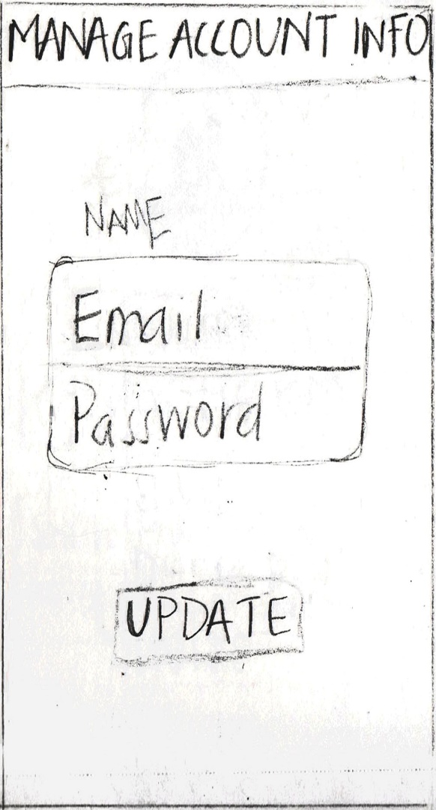**Manage Account Info Activity**

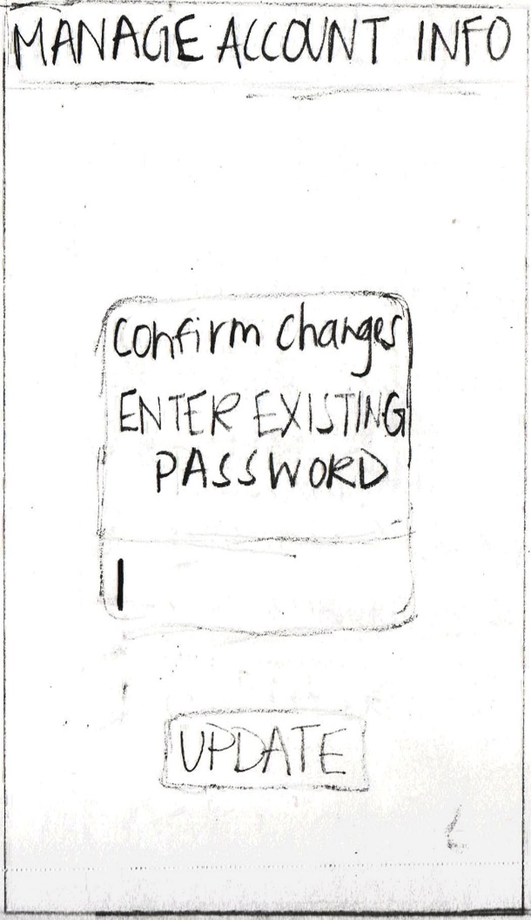

**

OPTIONS (Left):   
A. Enter New Name, and/or Email, and/or Password, tap “Update” Button, (Proceed to Right)

OPTIONS (Right):  
A. Enter existing Password in Dialogue Box, tap “Update” Button, (Return Page 8)

NOTES:  
*Needs Cancel Button*  
B. Tap “Cancel” Button to cancel, (Return Page 8)  
*Needs Error Screens for Blank and Valid Entries*

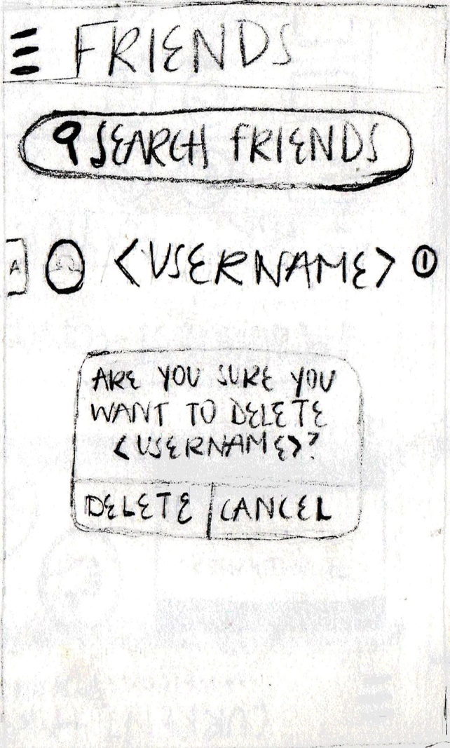**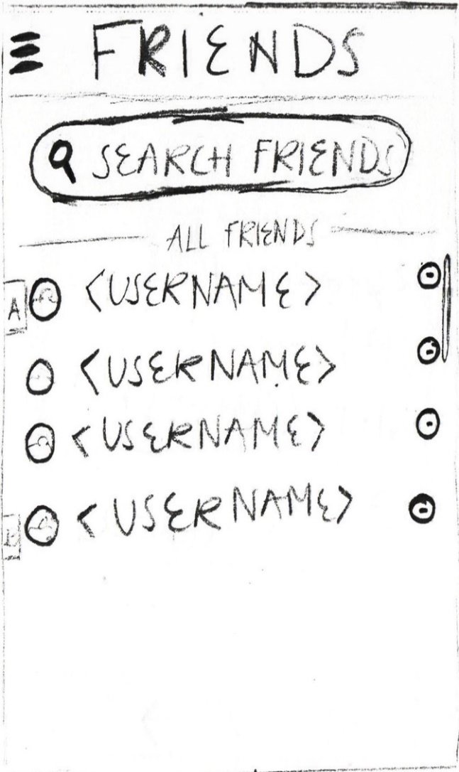Search Within Friends Activity**

OPTIONS (Left):   
A. Scroll through existing friends, select from existing friends (Proceed to Right)

NOTE (Left):   
*Add “+” Icon in top left corner*  
B. Tap “+” Icon to search for users, (Go Page 12(Left))

OPTIONS(Right):   
A. Tap “Delete Button” to delete friend, (Return to Left)  
B. Tap “Cancel Button” to cancel delete, (Return to Left)

NOTE (Right):  
*Potentially replace with “Friend’s Profile Activity”, On that friend’s profile, the same “Are you sure you want to delete…” dialogue box as is will appear when the “Friends” Button is selected*

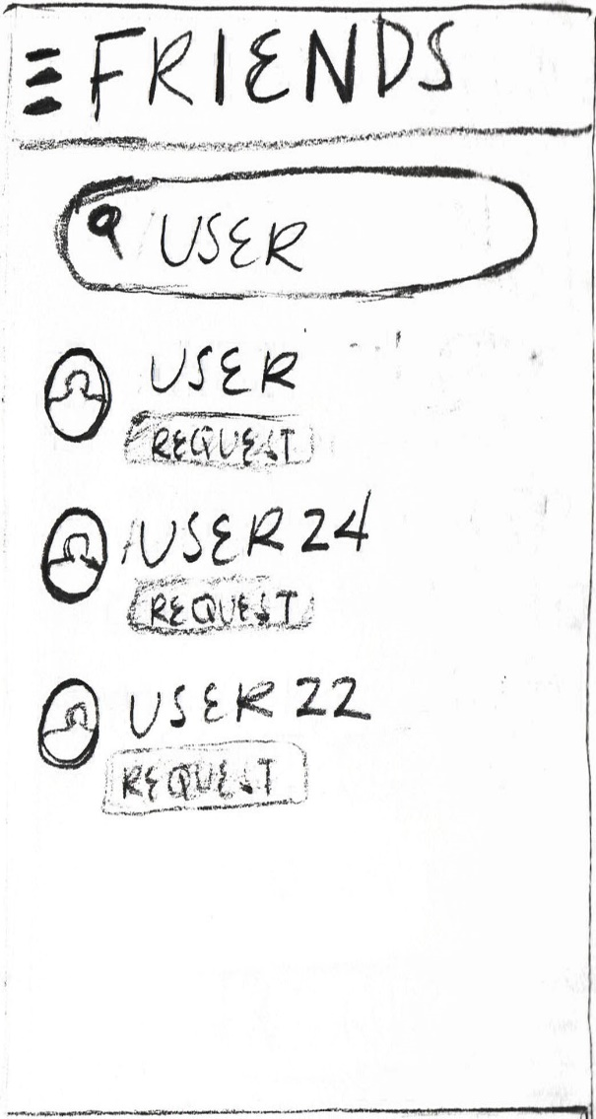**Search for Friends Activity**

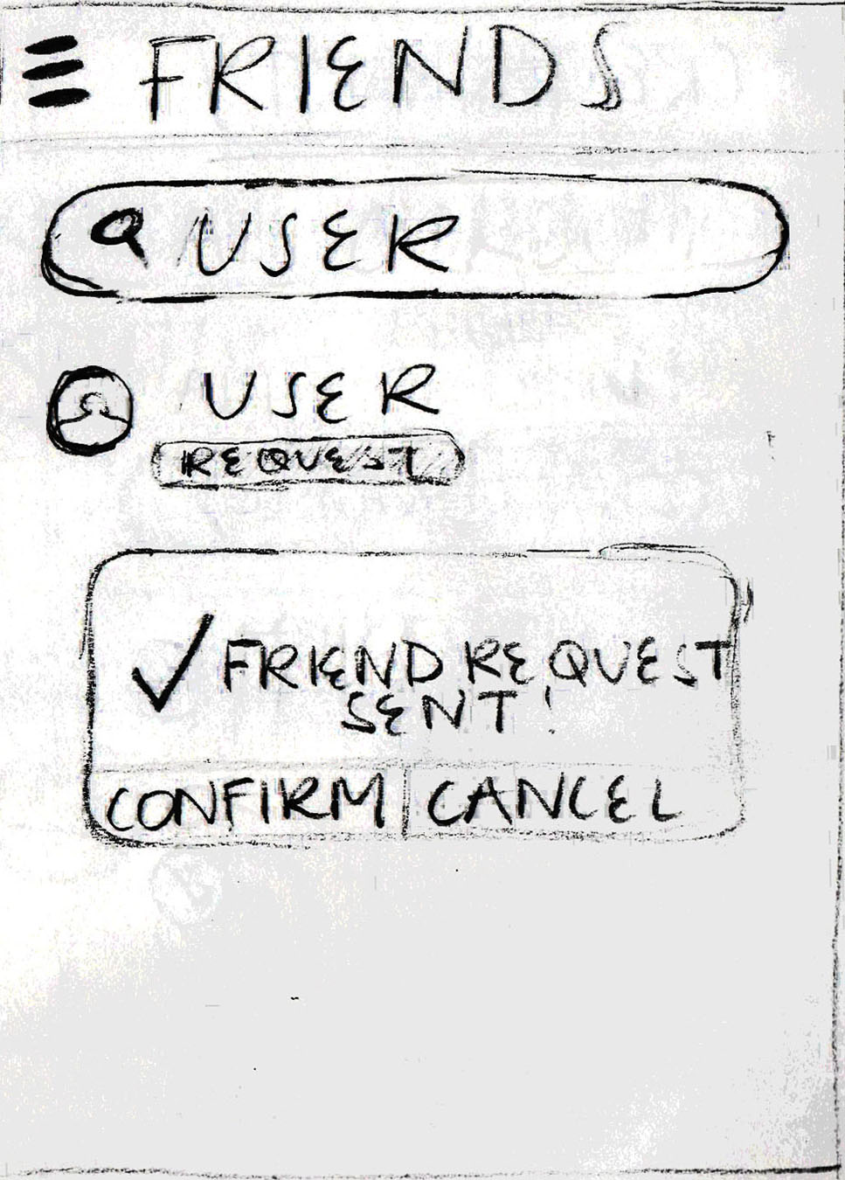OPTIONS (Left):  
A. Search for username via Search Bar  
B. Scroll within results  
C. Select from “Request” Button associated with desired username (Proceed to Right)

OPTIONS (Right):  
A. Tap “Confirm” Button to send request, (Return Page 11(Left))  
B. Tap “Cancel” Button to cancel request, (Return to Left)

NOTES:  
*Add “Go Back” Icon in top right corner*

**Hamburger Menu**

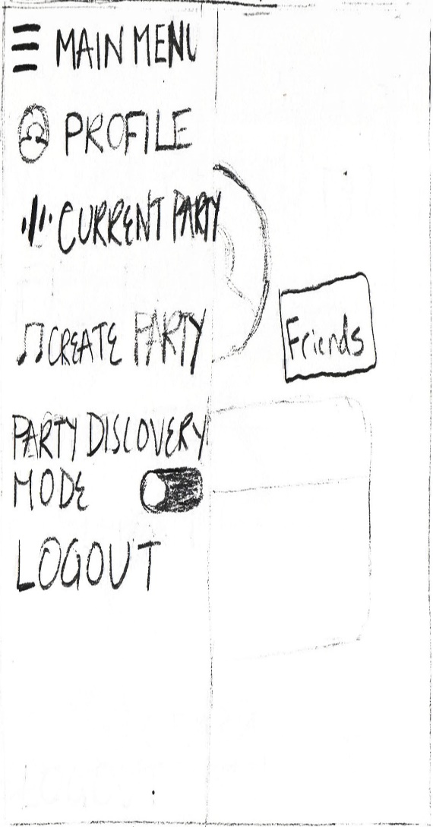

OPTIONS:   
A. Select “Profile” Button, (Return Page 5)  
B. Select “Current Party” Button, (Go Page 19)  
C. Select “Create Party” Button, (Go Page 14(State 1))  
D. Toggle on “Party Discovery Mode”, (Go Page 17)  
E. Select “Logout” Button, (Return Page 1)

NOTES:  
*Need “Are you sure you want to log out Dialogue Box” *  
*Only show “Current Party” Button when user is currently in party*

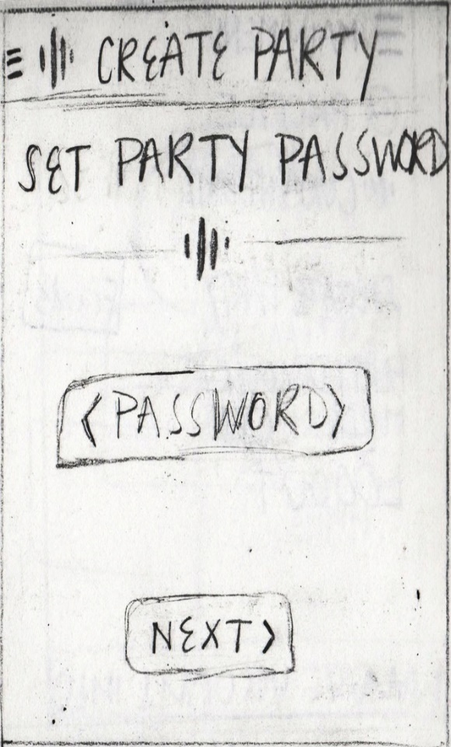**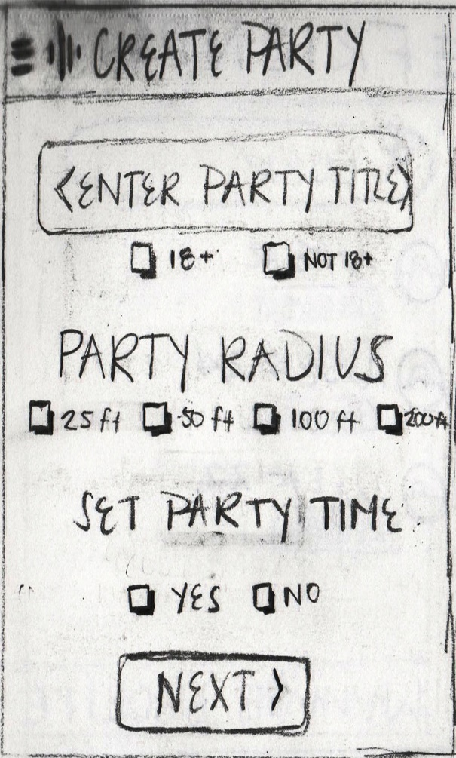Create Party Activity (States 1 and 2)**

OPTIONS State 1 (Left):  
A. Enter ‘Party Name’ in Party Title edit text  
B. Check either the “18+” or the “Not 18+” Checkbox  
C. Check desired Party Radius Checkbox  
D. Check either the “Yes” or the “No” checkbox under ‘Set Party Time’  
E. Tap “Next” Button, (Proceed to Right)

NOTES State 1:  
*Need Dialogue Box for Null/Invalid Party Title*

OPTIONS State 2 (Right)  
A. Enter Party Password, select “Next” Button, (Proceed Page 15(State 3))

NOTES State 2:  
*Need Dialogue Box for Null/Invalid Password*

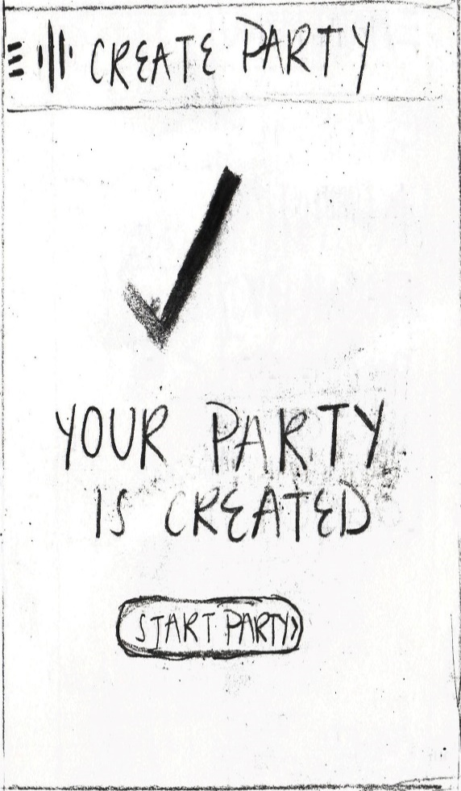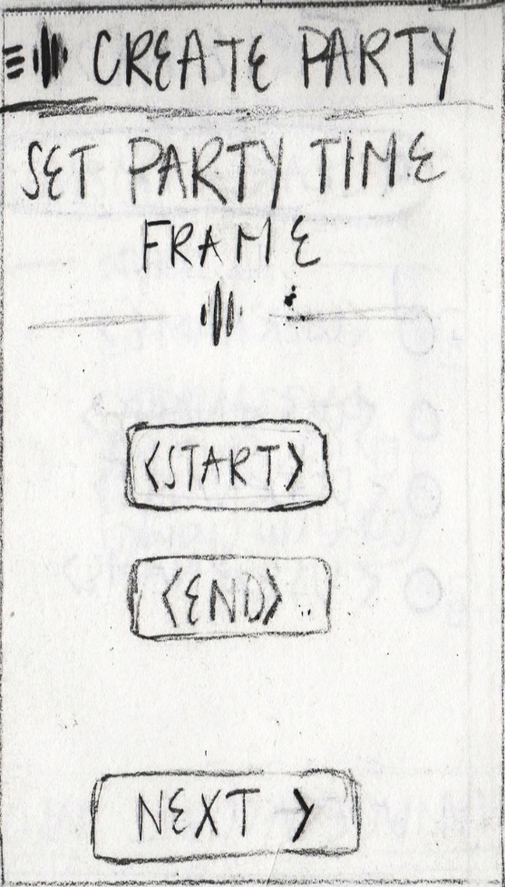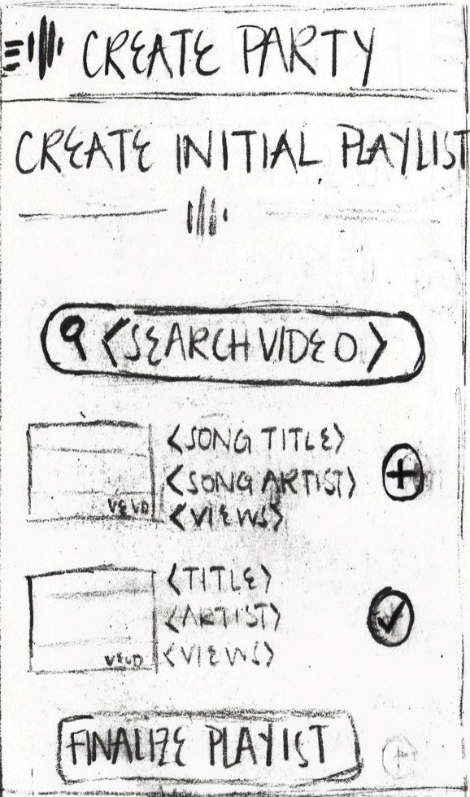**Create Party Activity (States 3, 4[optional], and 5)**

OPTIONS State 3 (Left):  
A. Search for Videos via Search Bar  
B. Select “+” icon next to desired video to insert into Playlist (“Checkmark” Replaces “+” Icon)  
C. Tap Finalize Playlist, (Proceed to Middle or Right depending on decision from Page 14 State 1)

OPTIONS State 4 (Middle):   
A. Enter Start and End time in edit texts, select “Next Button” (Proceed to state 5)

OPTIONS State 5 (Right):   
A. Tap “Start Party” Button, (Go Page 16)

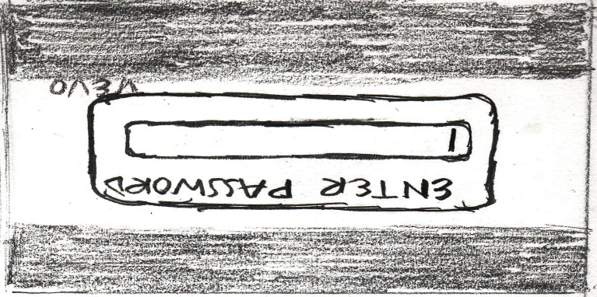**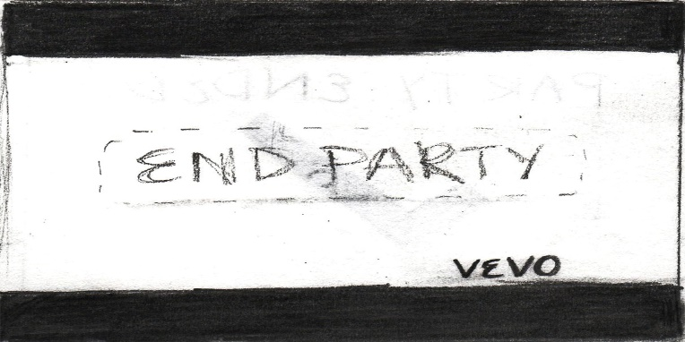Host Playlist Activity (States 1, 2, and 3)**

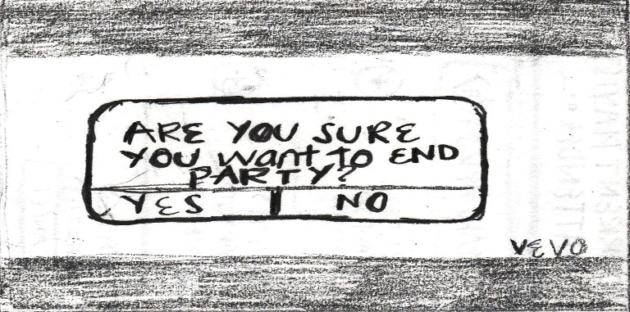

OPTIONS State 1 (Top Left):   
A. Select “End Party”, (Proceed to State 2)  
NOTES: *Change size and location of “End Party” Button*

OPTIONS State 2 (Top Right):   
A. Enter Party Password, (Proceed to State 3)  
NOTES:   
 *Need dialog box for incorrect password*

OPTIONS State 3 (Bottom Middle):   
A. Tap “Yes” Button, (Return Page 5)  
B. Tap “No” Button, (Return to State 1)

**Party Discovery Mode (States 1 and 2)**

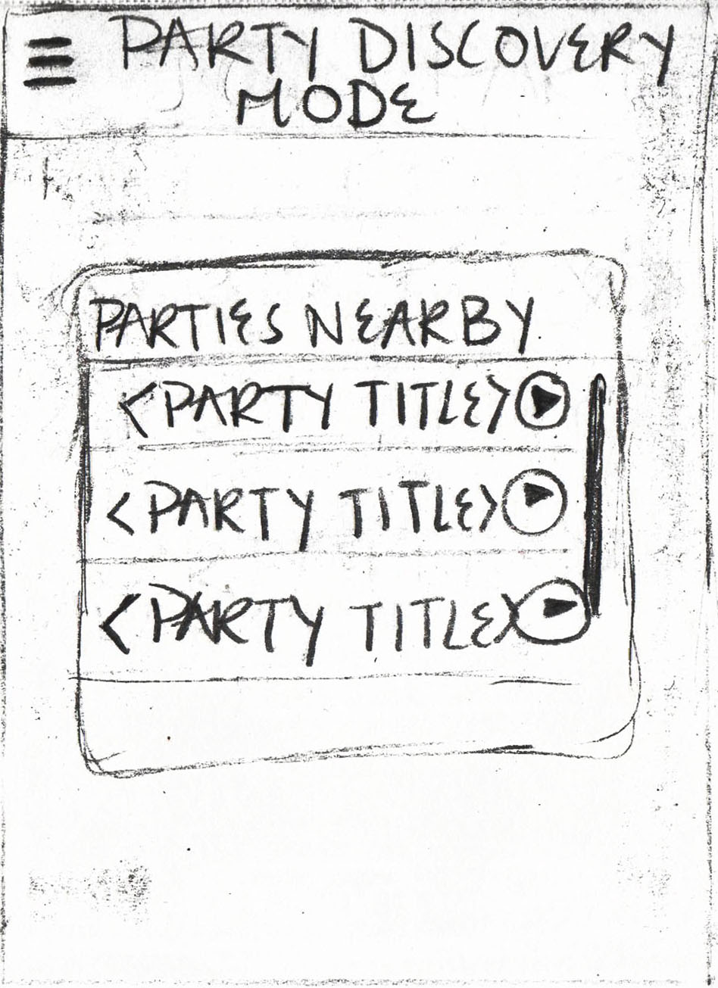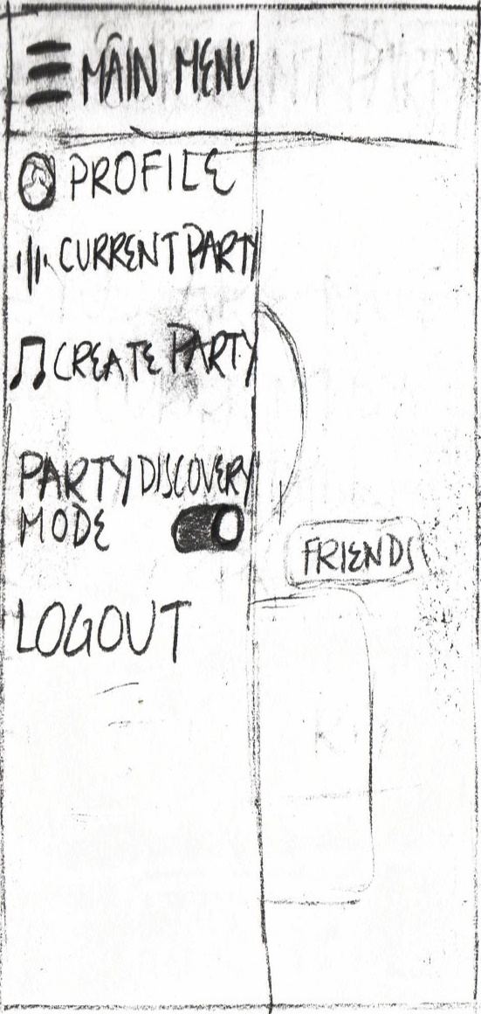

State 1 (Left): Party Discovery Mode has been Toggled On (Proceed to State 2)

OPTIONS State 2 (Right):  
A. Scroll within “Parties Nearby”  
B. Select from “Parties Nearby”, (Proceed to Page 18 State 3)

NOTE: enable devices GPS in order to divert from profile activity.

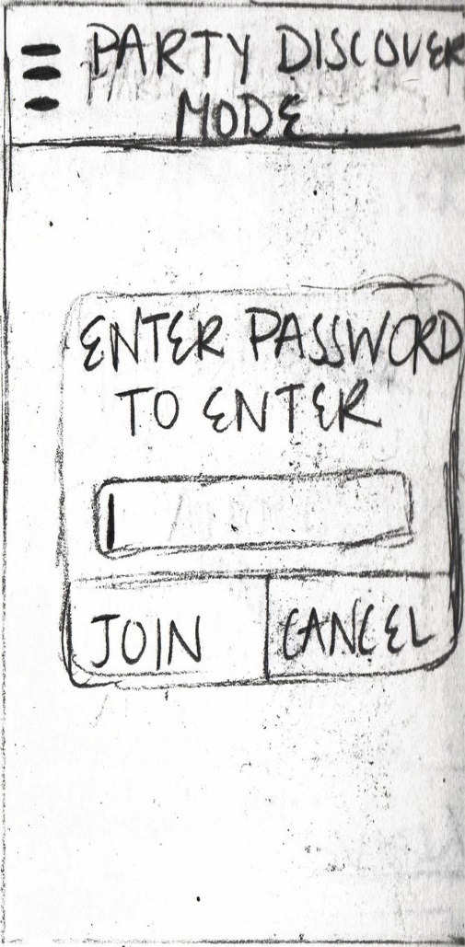**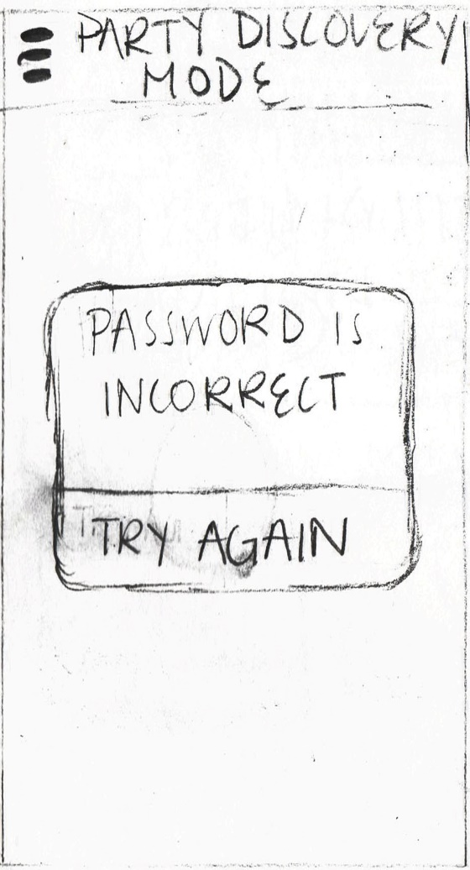Party Discovery Mode (States 3 and 4)**

OPTIONS State 3 (Left):  
A. Enter correct Party Password, tap “Join” Button, (Go Page 19)  
B. Enter incorrect Party Password, tap “Join” Button, (Proceed to State 4)  
C. Tap “Cancel” Button, (Return Page 13 *PDM disabled*)

OPTIONS State 4 (Right):   
A. Tap “Try Again” Button, (Return to State 3)

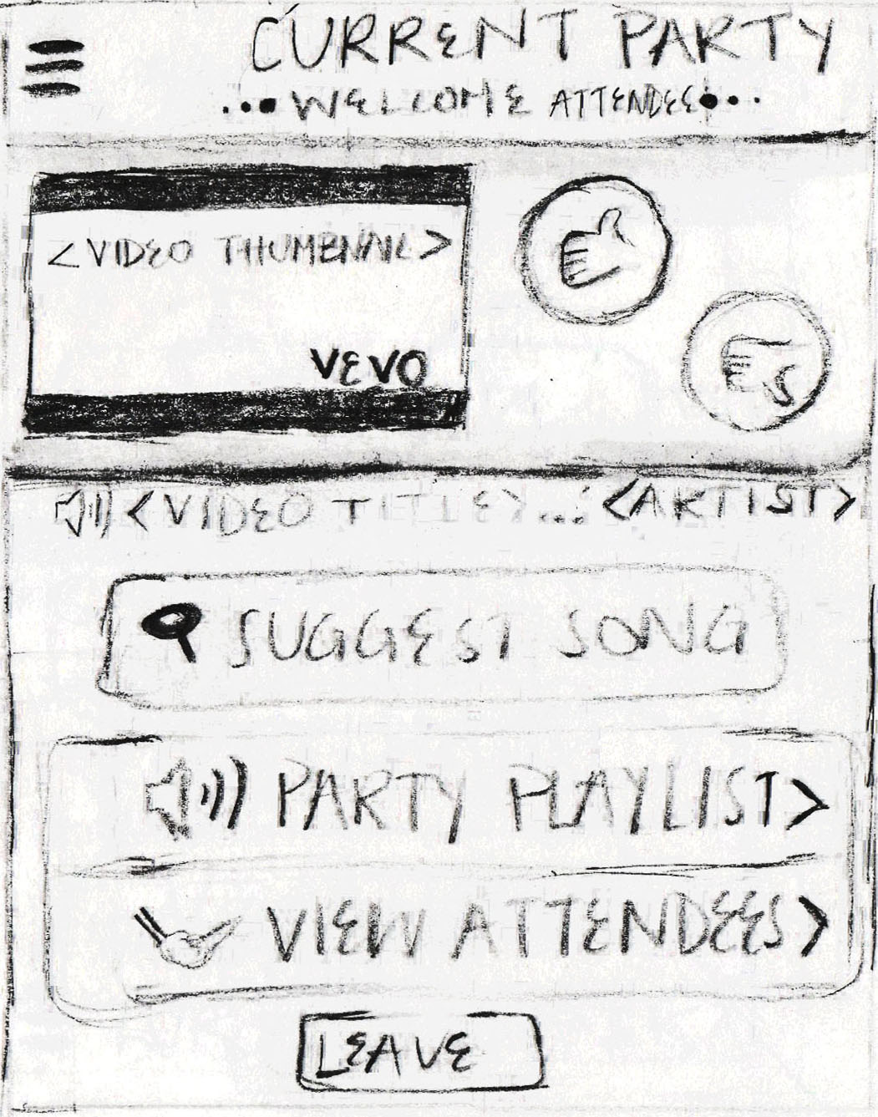**Attendee Party Activity**

OPTIONS:   
A. Tap “Thumbs-up” Icon to “Like” current video  
B. Tap “Thumbs-down” Icon to “Dislike” current video  
C. Expand “Party Playlist” dropdown, (Go Page 20 (Left))  
D. Expand “View Attendee” dropdown, (Go Page 20 (Right))  
E. Tap “Leave” Button to leave the Party, (Go Page 21 (Left)

NOTES:   
 *Need “Love Song” Icon*

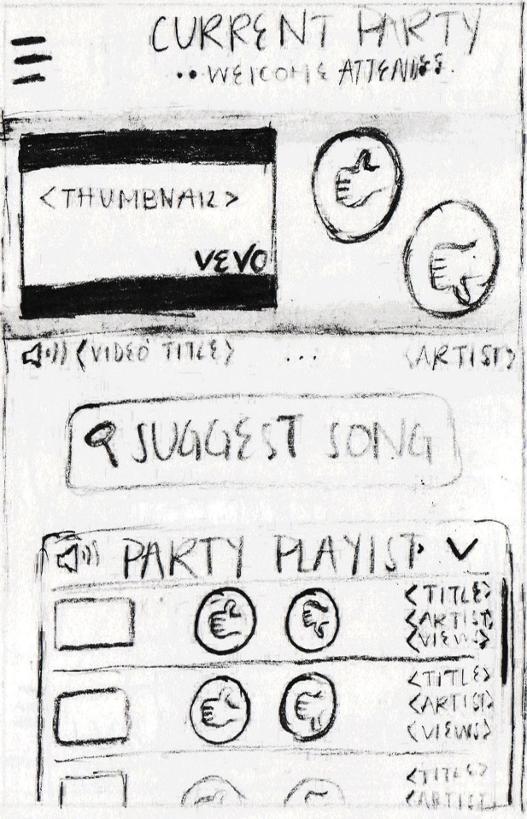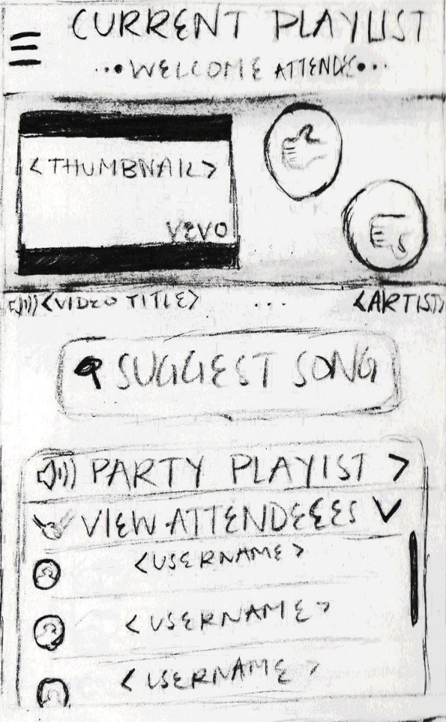**Attendee Party (‘View Party Playlist’ or ‘View Attendees’)**

OPTIONS View Party Playlist (Left):   
A. Scroll within Party Playlist  
B. Tap “Thumbs-up” Icon to “Like” Playlist Video  
C. Tap “Thumbs-down” Icon to “Dislike” Playlist Video

OPTIONS View Attendees (Right):  
A. Scroll within Attendees  
B. Select Username from dropdown

NOTES:  
*Need “Love Song” Icons*  
*(On Right) If selected Attendee is not currently friend, dialogue box appears asking if a friend request should be sent to the user. If users are already friends, direct user to “Friend’s Profile Activity”, (Go Page 11(Right)) *  
 *See pg 11 notes regarding ‘Friend’s Profile Activity’*

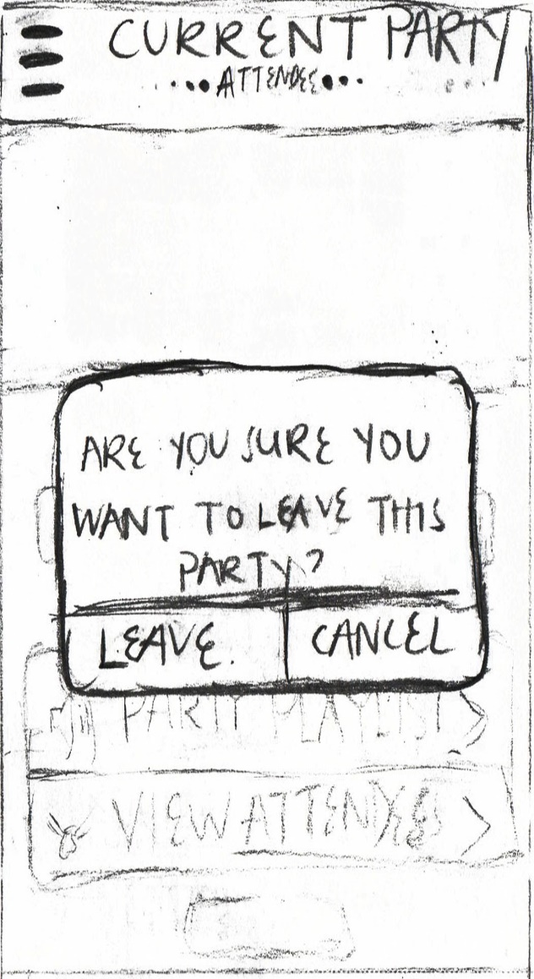**Attendee Leave Party (States 1 & 2)**

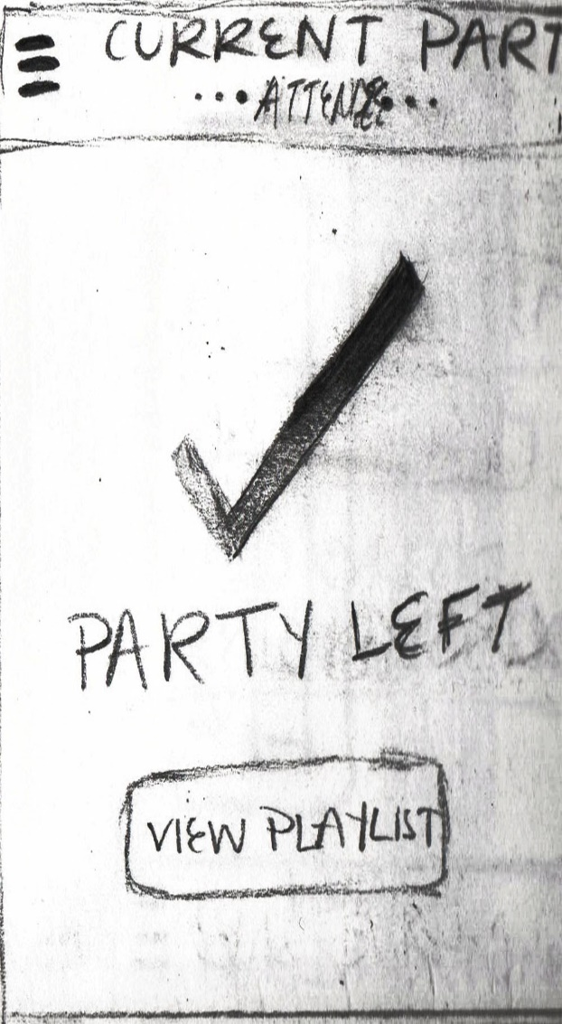OPTIONS State 1 (Left):  
A. Tap “Leave” Button, (Proceed to State 2)  
B. Tap “Cancel” Button, (Return Page 19)

OPTIONS State 2 (Right):   
A. Select “View Playlist”, (Return Page 6 (Left))

NOTES:   
*Maybe eliminate Right and instead, after “Leave” Button is pressed, direct the user to their Profile Activity with the “Show Parties” Dropdown expanded, (Page 6 (Left))

GENERAL NOTES:

* Need advertisement screens
* Still need ability to accept friend requests maybe put this option in hamburger menu